MACKENZIE L. WATTS MEMORIAL SCHOLARSHIPS SOCCER, CHOIR AND SWIMMING/DIVING

APPLICATION DEADLINE March 24, 2023
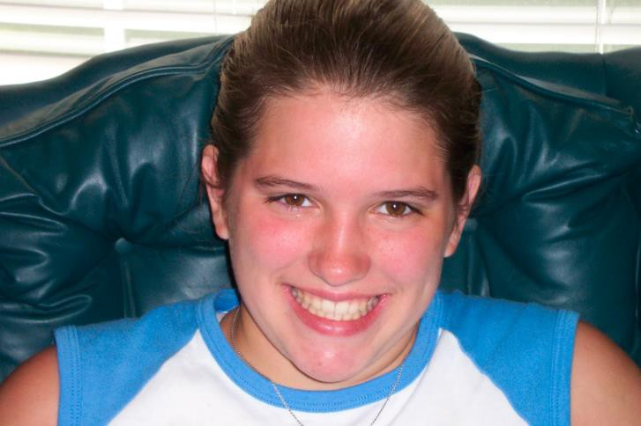
Mackenzie L. Watts
May 22, 1990 ~ November 21, 2005

Mackenzie was born in Owosso, Michigan, the daughter of George and Laurie Watts.

Mackenzie made the people and world around her better. She was a friend to all who knew her and the impact of her life extended far beyond those. Whether she was in the classroom, at church, in the pool, or singing in the choir, Mackenzie approached life with such heart that an entire room would smile at her presence.

A natural leader, Mackenzie was constantly supportive of her peers in any situation. She could be counted on for sound advice, words of encouragement, or an open ear. She was sincere, welcoming, and lived every day with an enthusiasm only matched by her trademarked smile.

Mackenzie was also a hard worker, determined to give it her all until her goals were accomplished. She faced every new challenge, tackled every new problem, and climbed over any barrier with joyful optimism and full commitment.

Mackenzie was a true role model and set an example for others to strive for. Coaching young children, mentoring teammates, modeling dedication, piety, compassion and determination, Mackenzie, in her fifteen years on earth, demonstrated a life we should all try to emulate.

SCHOLARSHIP CRITERIA

- Scholarships shall be awarded to seniors in good standing from a high school in the Howell Public School District
- Applicants must be in good standing/credit eligible for commencement and diploma from Howell Public Schools
- Grade point average of a “B” or better (3.0 or higher)
- Proven record of community service
- Proven record of leadership role in school, organization, or team (school organization officer, student council, or team captain).

The following three scholarships are offered from this fund:

  - CHOIR SCHOLARSHIP (Male or Female): Varsity choir member with a minimum three years participation in the choir program.

  - SOCCER SCHOLARSHIP (Male or Female): Varsity soccer team member with a minimum of two years participation on the soccer team, one of them being their senior year unless a medical/physical condition prohibits participation senior year; then only the senior year participation requirement is waived.

  - SWIMMING/DIVING SCHOLARSHIP (Female): Women’s varsity swim team member with a minimum of two years participation on the swim team, one of them being their senior year unless a medical/physical condition prohibits participation senior year; then only the senior year participation requirement is waived.

Scholarship Application Instructions
Scholarships are available through the Shiawassee Community Foundation thanks to the generosity of donors who have established scholarships funds. The original donor determines the eligibility criteria of their scholarship fund.

Applications for the Watts Scholarship are due by March 24, 2023.

    - Documented admission to an accredited two- or four-year college.

    - One-page essay on your high school experience as it relates to the requirements for community service, leadership and your role on the Swim Team, Soccer Team, or Choir Program

    - A typed resume is required. Please include the following information:

      - Academic/scholastic activities (clubs, student government, National Honor Society, etc.)
      - Sporting activities
      - Extracurricular and community activities (civic activities, clubs, volunteer work, etc.)
      - Number of years you have participated in the activities and your leadership position, letters earned, awards received and recognitions.
      - Work experience including name of employer, nature of work, positions held and dates employed.

    - One official copy of your high school transcript is required.

    - Incomplete applications and applications that arrive after the deadline will not be reviewed.

    - Scholarship monies must be used in the 2023-2024 school year (July 1, 2023 – June 30, 2024) unless permission is granted by the foundation in advance.

    - The SCF Board of Directors reserves the right to extend any and all scholarship deadlines at their discretion.

    - All scholarships will be made on an objective and nondiscriminatory basis from a pool of persons chosen based on the criteria of this fund.

MACKENZIE L. WATTS MEMORIAL SCHOLARSHIP FUND APPLICATION

Name: Street Address:

City:
State:
Zip:

Home Phone: Cell Phone:

Email Address: High School: Graduation Year:
Cumulative GPA: SAT Score:

Date of Birth:
Male
Female

COLLEGE/UNIVERSITY INFORMATION
College you plan to attend: Intended major/minor:

Full Time Student? Yes
No
If no, # of credits per semester:

Please place a checkmark next to the scholarship you are applying for.

- Choir Scholarship
- Soccer Scholarship
- Swimming/Diving Scholarship FAMILY INFORMATION
Name of Parents/Guardians: Father’s Employment: Mother’s Employment:

CERTIFICATION

I hereby affirm that the information provided in this application is accurate and complete to the best of my knowledge.

Applicant Signature Date Signed

Printed Name

Before you submit this application, please review the checklist below to ensure the scholarship application is complete and all required information is included.

- Application form must be filled out completely. Applications must be neat and legible and be either typed or printed in blue or black ink.

- Documented admission to an accredited two- or four-year college.

- One-page personal essay

- Current resume

- High school official transcript of grades

SEND COMPLETED APPLICATIONS TO:
Shiawassee Community Foundation 217 N. Washington St. Suite 104 Post Office Box 753
Owosso, MI 48867 OR
Turn in to the Howell High School Counseling Office

SCF CONTACT INFORMATION: Phone: 989-725-1093
Email: kim@shiacf.org
Website: www.shiacf.org

