DEBRA WEGMAN MEMORIAL FUND

Grant Application

Due November 15, 2022 @ 4:00 pm
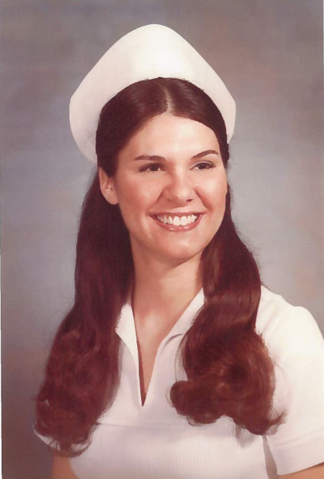

This fund was started by Debra’s husband (Dr. Patrick Wegman) and son (Patrick Wegman II) on the 10th anniversary of her passing as a way to commemorate her life and give back to the community that has nurtured their family for so many years.
The purpose of this fund is to assist programs focusing on healthcare, education, arts and theatre, community improvement, ministry and spiritual enrichment, beautification projects (especially water-related), youth programs, senior programs, or programs serving other unmet charitable needs.
Grants are awarded to qualifying organizations including non-profits that are tax-exempt under Section 501(c)(3) of the Internal Revenue Code, schools, municipalities, and other governmental entities that serve a charitable purpose.

Date:
Legal Name of Organization:
Street Address:
City, State, Zip:
Phone:
Website:
Tax ID Number:
Grant Amount Requested:
CONTACT INFORMATION
Name:
Phone:
Email:

GRANT APPLICATION NARRATIVE

Please attach a narrative answering the following questions. Be as clear as possible when describing your proposed project.

- What project or program will the requested grant money be used for? Please describe.
- What is the timetable for implementation of this project?
- What outcomes do you hope to achieve with this project? How will you evaluate the success of the project?

__________________________________________ ______________________________________
Authorized Signature Title

Today’s Date: _____________________________

REQUIRED ATTACHMENTS
- Project Budget - be specific about how grant funds will be spent if awarded

- IRS determination letter or proof of the organization’s structure

- Current list of governing body and officers of the organization

- Most recent financial statements or tax return of the organization

- Include a list of other partners (if any) in the project and their roles

- For Student/School Organizations Only:
  - List of officers of the student organization and adult advisor/coach
  - Letter of support from the school principal or superintendent

FINAL CHECKLIST
Before submitting your application, be sure you have included the following:

- Grant application form (pages 1 and 2)
- Narrative
- Required attachments

Return completed grant application and required documents to:
Please submit the grant application and the following required information to the Foundation office by the deadline. In order to receive consideration for grant funding, applications must be complete and include all required documentation. Applications may be mailed, emailed, or delivered in person; the Foundation does not accept faxed applications. It is the applicant’s responsibility to confirm receipt of the application.

By Mail: Shiawassee Community Foundation
P.O. Box 753
Owosso, MI 48867
(Must be postmarked no later than November 15, 2021)

In Person: Shiawassee Community Foundation
217 N. Washington Street, Suite 104
Owosso, MI 48867
(Office hours are Mon to Fri, 9am–4pm)

By Email: kim@shiacf.org

Please direct questions to Kim Renwick at
(989) 725-1093 or kim@shiacf.org
www.shiacf.org

REQUIRED DISCLOSURES:

The Shiawassee Community Foundation Board of Directors reserves the right to extend any and all grant deadlines at their discretion. They also reserve the right to not award any and all grants in any given year.
Completing and submitting a grant application does not guarantee an award.
All grants will be made on an objective and nondiscriminatory basis determined by the criteria of each respective fund.
Grant amounts vary each year depending on available funding.
All grant application information submitted to SCF is handled in a strictly confidential manner.
Grant Selection Committee members are required to sign a Confidentiality Statement indicating that they will keep all application information confidential.
If funded, you will be required to submit a Final Grant Report to SCF detailing how the grant money was spent (documented with receipts) and how successfully the project achieved its proposed outcomes.
Applications may be disqualified if the applicant has an outstanding final grant report from a previous grant. Please contact our office if this is the case.

For SCF Office Use Only:
Date Received: | FIMS Grant Number:
Amount Approved: | Date of Board Approval:
Issue Grant Check To:

