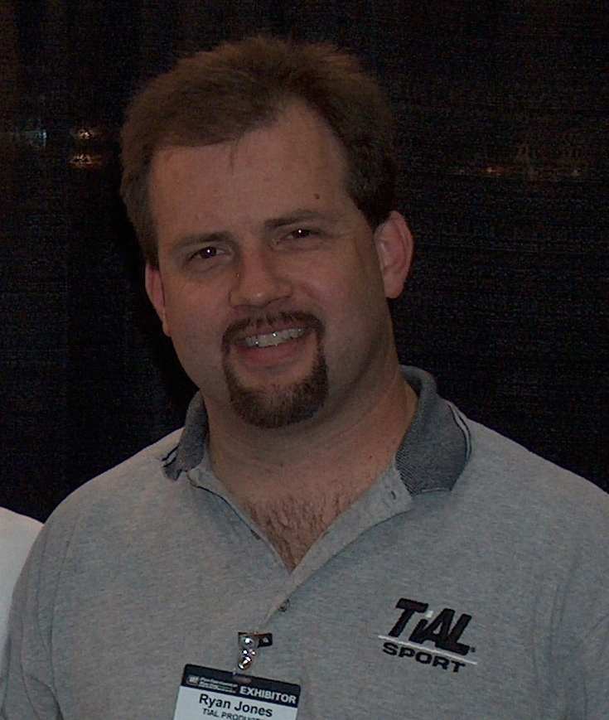
Ryan Jones Memorial Fund
ALS Grant Application

—Applications accepted year-round—

Ryan Jones was co-owner of TiAL Products in Owosso, where he enjoyed working side by side with his brother, Gregg. Ryan was diagnosed with Amyotrophic Lateral Sclerosis (ALS) and passed away at the age of 43.

The purpose of this fund is to benefit patients diagnosed with ALS to improve their quality of life. By way of example and not limitation, this may include any of the following:

- Augmentative/alternative communication devices, such as speech-generating devices, electronic communication aids, voice amplifiers, dedicated communication devices, thought transference devices (TTD), software and hardware, specialized keyboards, movement and eye-activated switches, teletypewriters (TTY)/telecommunications device for the deaf (TDD), mouth sticks, and other assistive technology;

- Comfort measures such as non-invasive positive pressure ventilation (NIPPV) (nasal mask assisted breathing), hospital beds, etc.;

- To provide safe mobility options, such as canes, walkers, manual or power wheelchairs, wheelchair ramps, lift chairs, and handicap-accessible transportation;

- To provide education and training to patients and caregivers;

- To provide counseling, physical therapy, and occupational therapy;

- To provide financial assistance to obtain prescription and non-prescription medications or speech therapy to treat or alleviate mental and physical symptoms and pain.

- Grants shall not be used to fund ALS research.

The Foundation is pleased to be able to help patients with ALS in need of assistance. Please note that grants are paid directly to vendors and will not be awarded to individuals.

APPLICANT INFORMATION
Date:
Patient Name:
Street Address:
City, State, Zip:
Phone:
Email:
Date of ALS Diagnosis:
Caregiver Name:
Caregiver Phone:
Grant Amount Requested:

Describe the purpose of the proposed ALS Grant:
(You may use additional pages if necessary)

Cost of Equipment, Services, and/or Supplies:
(Please attach a copy of the quote)

Signature of Applicant/Caregiver: __________________________________________

Please print name clearly: __________________________________________

REQUIRED ATTACHMENTS
AL CHECKLIST
- Note from your physician confirming a diagnosis of Amyotrophic Lateral Sclerosis (ALS) and date of diagnosis.

- The applicant must provide an estimate obtained from the supplier for the cost of the requested equipment, services, and/or supplies.

- Quote for equipment, services, and/or supplies.

FINAL CHECKLIST

Before submitting your application, be sure you have included the following:

- Grant application form (pages 1 and 2)
- Narrative (if you needed to attach an additional page)
- Required attachments

Return completed grant application and required documents to:

Please submit the grant application and the following required information to the Foundation office by the deadline. In order to receive consideration for grant funding, applications must be complete and include all required documentation. Applications may be mailed, emailed, or delivered in person; the Foundation does not accept faxed applications. It is the applicant’s responsibility to confirm receipt of the application.

By Mail: Shiawassee Community Foundation
P.O. Box 753
Owosso, MI 48867

In Person: Shiawassee Community Foundation
217 N. Washington Street, Suite 104
Owosso, MI 48867
(Office hours are Mon to Fri, 9am–4pm)

By Email: kim@shiacf.org

Please direct questions to Kim Renwick at
(989) 725-1093 or kim@shiacf.org
www.shiacf.org

REQUIRED DISCLOSURES:

The Shiawassee Community Foundation Board of Directors reserves the right to extend any and all grant deadlines at their discretion. They also reserve the right to not award any and all grants in any given year.
Completing and submitting a grant application does not guarantee an award.
All grants will be made on an objective and nondiscriminatory basis determined by the criteria of each respective fund.
Grant amounts vary each year depending on available funding.
All grant application information submitted to SCF is handled in a strictly confidential manner.
Grant Selection Committee members are required to sign a Confidentiality Statement indicating that they will keep all application information confidential.

For SCF Office Use Only:
Date Received: | FIMS Grant Number:
Amount Approved: | Date of Board Approval:
Issue Grant Check To:

