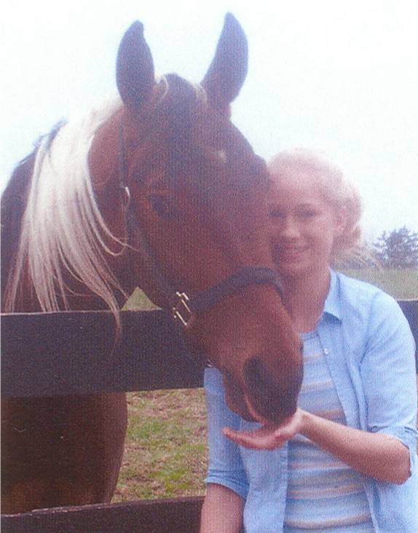
KAILEY ELIZABETH JORDAN Memorial Fund

Grant Application

This application is open year-round

Kailey lost her life at the age of 16 in a car accident. She was a junior at Durand High School and was active in tennis, soccer, track, cross country, volleyball, and yearbook. Her love of horses led her to compete with several organizations. After graduating from high school, Kailey wanted to further her education in either horse training or photography.

The purpose of this fund is to award grants in Kailey’s memory to accredited Michigan horse camps to allow Michigan disabled or terminally ill children (ages 16 and under) to benefit from therapeutic horseback riding.

APPLICANT INFORMATION
Date:
Applicant Name:
Applicant’s Guardian Name:
Street Address:
City, State, Zip:
Phone:
Email:
Applicant Age:
Specific Disability and/or Limitation:
Total Annual Family Income:
(AGI from last tax return)

HORSE CAMP INFORMATION
Horse Camp Name:
Contact Person:
Street Address:
City, State, Zip:
Phone:
Dates of Riding Sessions:
Total Cost:
Amount Requested:

GRANT APPLICATION NARRATIVE

Please attached a 100–500 word essay describing how therapeutic horseback riding will benefit the applicant’s specific disability. This essay may be completed by applicant and/or guardian. Financial need will be considered. If awarded, grant checks will be mailed directly to the horse camp on behalf of the applicant.

FINAL CHECKLIST

Before submitting your application, be sure you have included the following:

- Grant application form (pages 1 and 2)
- Narrative
- Required attachments

Return completed grant application and required documents to:
Please submit the grant application and the following required information to the Foundation office by the deadline. In order to receive consideration for grant funding, applications must be complete and include all required documentation. Applications may be mailed, emailed, or delivered in person; the Foundation does not accept faxed applications. It is the applicant’s responsibility to confirm receipt of the application.

By Mail: Shiawassee Community Foundation
P.O. Box 753
Owosso, MI 48867

In Person: Shiawassee Community Foundation
217 N. Washington Street, Suite 104
Owosso, MI 48867
(Office hours are Mon to Fri, 9am–4pm)

By Email: kim@shiacf.org

Please direct questions to Kim Renwick at
(989) 725-1093 or kim@shiacf.org
www.shiacf.org

REQUIRED DISCLOSURES:

The Shiawassee Community Foundation Board of Directors reserves the right to extend any and all grant deadlines at their discretion. They also reserve the right to not award any and all grants in any given year.
Completing and submitting a grant application does not guarantee an award.
All grants will be made on an objective and nondiscriminatory basis determined by the criteria of each respective fund.
Grant amounts vary each year depending on available funding.
All grant application information submitted to SCF is handled in a strictly confidential manner.
Grant Selection Committee members are required to sign a Confidentiality Statement indicating that they will keep all application information confidential.

For SCF Office Use Only:
Date Received: | FIMS Grant Number:
Amount Approved: | Date of Board Approval:
Issue Grant Check To:

