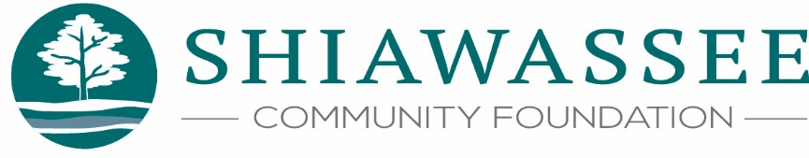

Privacy Policy

The Shiawassee Community Foundation (“the Foundation”) is committed to protecting your privacy to the greatest extent possible. If you have any questions about this privacy policy, please contact our office:
217 N. Washington Street, Suite 104
Owosso, MI 48867
(989) 725-1093
lisa@shiacf.org

How We Obtain Your Information
We may acquire your personal data from information you provide on a scholarship application, grant application, or in connection with a donation. This may include contact information, financial contribution data, and scholarship or grant application status.

How We Use and Protect Your Information
We take every precaution to maintain the confidentiality of our donor, applicant, and grantee information. Therefore, we do not sell or rent your information to any third parties. Some of our donations are processed by a third-party service provider such as PayPal. Your information is only used as necessary to process your donation transaction. For more information about how these third-party providers use and protect your personal information, we recommend reviewing their respective privacy policies.
We do publish a list of all donors, fund names, scholarship winners, and grantees in our Annual Report, on our website, and in various social media posts throughout the year. These posts include the names and dollar amounts of scholarships and grants awarded, but do not include contact information or donation amounts. We may also share the personal information we collect with government agencies or other regulatory bodies as required by law.
If you would not like your name listed as a donor in our Annual Report or on our online media channels, please let us know. You also have the option of asking us to list your donation as anonymous.

