How to Donate to a Specific Fund

We strive to make the process of supporting the Foundation as simple as possible. Please see the guide below for a step-by-step outline of our most frequent types of gifts.

Cash:
Cash donations may be made in person and dropped off at: 217 N. Washington St., Suite 104
(Office Hours: M-F 9-4) Owosso, MI 48867

Check:
Donations via check are the most common form of gift received. Due to banking regulations, checks need to be made payable to the Shiawassee Community Foundation. In the “memo” line, please write the name of the fund for which the donation is intended. Donations via check should be sent to P.O. Box 753, Owosso, MI 48867; or dropped off at the address above.


Shiawassee Community Foundation

ABC Fund

Below is a sample of the envelope that is available through the Shiawassee Foundation used for giving donations. If you do not have an envelope, the information below would be helpful to determine the intended use of the donation.
Enclosed is my gift of $______________

My Name(s) as I would like it to appear on acknowledgement:

Name

Address

City/State/Zip

E-mail address

Phone (optional) simply select the fund or scholarship and click “Donate” again above this selection

Please make checks payable to: Shiawassee Community Foundation.
Gifts are tax deductible.

This gift is made
__TO: The Shiawassee Community Foundation

____________________________________________________
(Name of fund, if desired)
____________________________________________________

___In memory of ___In honor of ___Special occasion

____________________________________________________
Please list name

Please notify of gift (amount will NOT be mentioned)

_____________________________________________________
Name
_____________________________________________________
Address
______________________________________________________
City/State/Zip
Enclosed is my gift of $_______________________

My Name(s) as I would like it to appear on acknowledgement:

___________________________________________________
Name (please print)

___________________________________________________
Address

___________________________________________________
City/State/Zip

___________________________________________________
E-mail address

___________________________________________________
Phone

Please make checks payable to: Shiawassee Community Foundation.
Gifts are tax deductible.

Credit Card:
STEP 1: Making gifts to a fund via debit/credit card is now easier than ever. Visit our website, www.shiacf.org and click “Donate”.


STEP 2: Next, select a fund/scholarship of your choice from the drop down box. If you do not have a fund preference, please select “Unrestricted Fund” at the top of the selection listings.

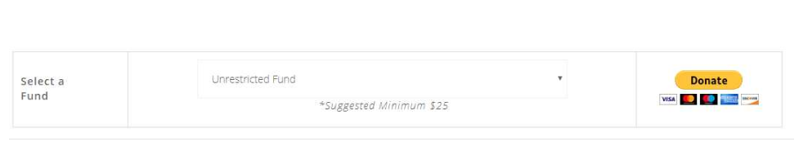
Select a
Fund
Unrestricted Fund

*Suggested minimum $25

STEP 3: Click “Donate” again and you will proceed to the donation platform Paypal, which will walk you through their payment information. Once completed, tap “Donate Now” and your donation will be sent to the Foundation. A confirmation e-mail will be sent to you after completion.
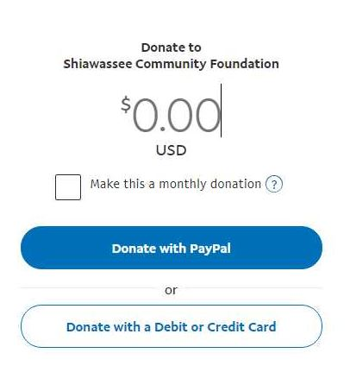
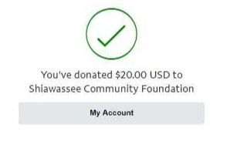
Please feel free to call Kimberly Renwick at 989-725-1093 or email- kim@shiacf.org if you have any questions.

